# Analysis about AXON company

## What are my observations about AXON company:

Axon, which is a retailer selling classic cars. The management is unable to get accurate and up-to-date sales reports, which is affecting the decision-making process.to resolve this I used power bi tool and SQL. first installed SQL version which is power bi supports to get data from SQL to power bi. go to power bi get data option click on my SQL workbench. provide server and database name, navigator window opened. used to do transform data in power query editor. Remove null values, set first rows as column headers and load data. Check data types, converted some columns datatypes which are wrong. remove no need columns by right click on column name select delete. combined columns through merge columns in power query editor. merge queries.in view checked column quality, distribution. checked valid percentage, error percentage, empty in column. Checked relation among the tables. if no relation checked in manage relationships.it automatically detected the relations. if no relationship, drag and drop common columns. if relationships are correct, we get calculations correctly. Created measures, Quick measures

## 

Above report is describes about which product line ordered in which quantity.

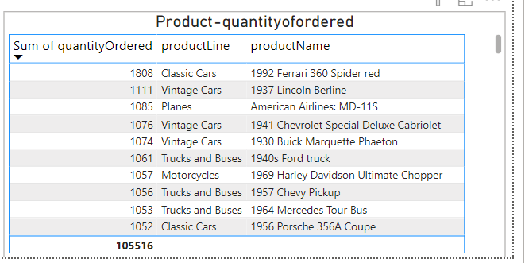

Above report describes which product ordered in which quantity.

Based on these above two reports:

1.The highest quantity ordered product line is Classic Cars. And the highest ordered

product is 1992 Ferrari 360 Spider red is 1808 cars. The product code is S18_3232.

It is the most demanded car type in 2003-2005.

2.Surpraisingly less qunatity ordered productline is also Classic Cars. And the less ordered product is 1957 Ford Thunderbird is 767 cars. The product code is S18_4933.

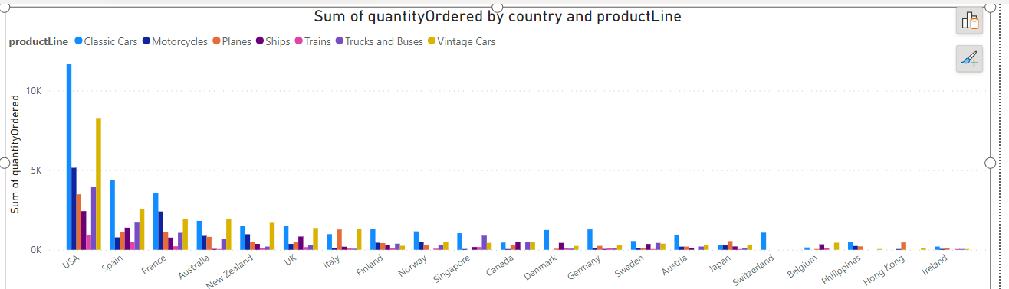

Above report describes which country ordered most products and which productline ordered most by that country.

1. Max orders done by USA 35844,

max ordered productline is Classic cars 11655,

min ordered productline is Trains 912.

2.Min orders done by Ireland 490,

max ordered productline is Classiccars 202.

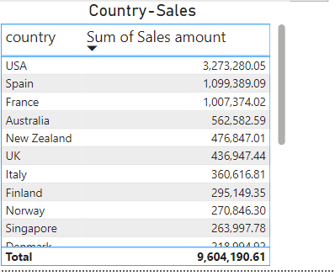

Above report describes about country sales amount

1.Highest sales spent by USA 3,273,280.05 followed by Spain, France, Australia.

2.lowest sales spent by Hongkong 45,480.79

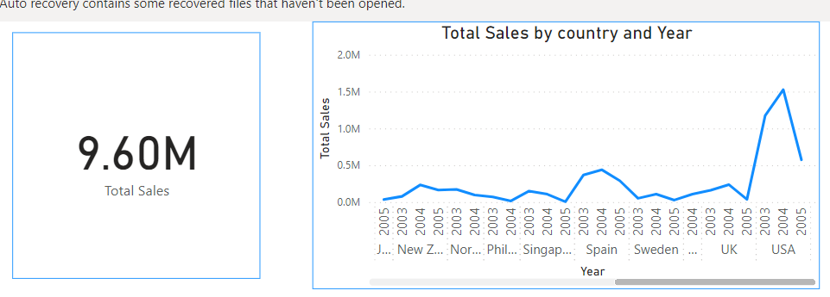

Above reports describes about total sales and countries sales in years 2003, 2004, 2005.

1.Total sales spent by all countries is 9.60M. In these USA spent Highest Sales Amount 3.2M In 2003-2005.In 2004

USA spent highest Amount above 1.5M.

2.All sales increased in 2004 from 2003.In especially Most of the sales are increased in the Month November.

In 2005 there is decrease in sales.

3.After USA Spain, France, Australia are followed highest sales countries.

4.In 2004 got Highest Orders 1552910.

In 2003 got second highest orders 1127481

In 2005 got least orders year 665184

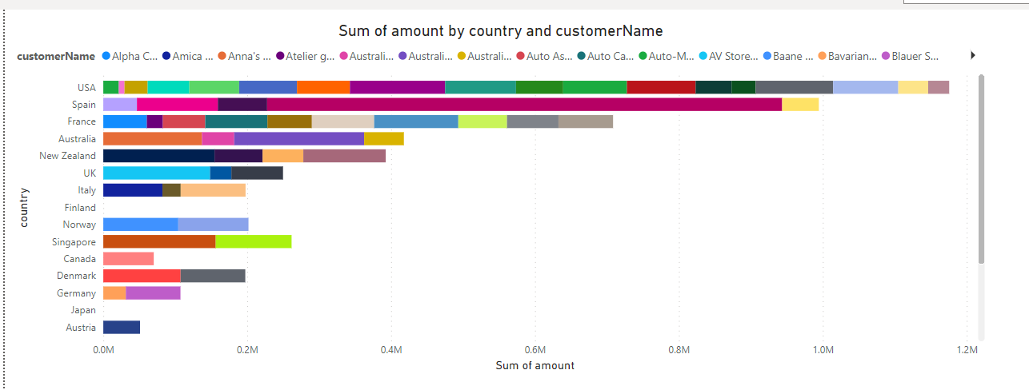

Above report describes about amount paid by customer and his country

1.max amount spent by customer Euro+shopping channel from Spain, sum of amount he spent was 715,738.98

The company can offer any exclusive discounts on next purchase of this customer because he spent the highest

amount on this company

2.min amount spent by customer Boards &Toys Co. from USA, sum of amount he spent was 7,918.60

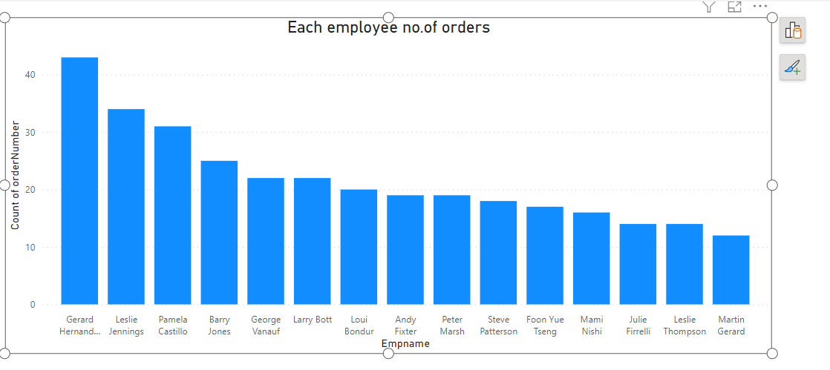

Above reports describes about each employee got how many orders.

1.In Axon company no.of employees are working. But in all of these workers ,

The highest orders got Employee is Gerard Hernandez is 43 Order numbers.

2.company can give him good salary increments for his good work.

3.The lowest order numbers have by Martin Gerard is 12.

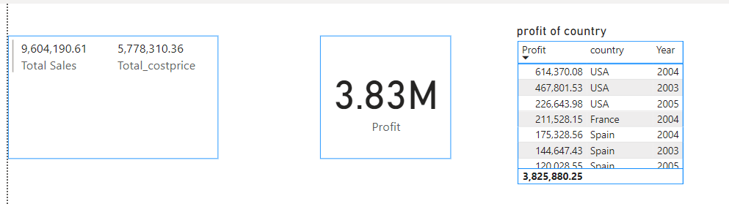

Above report describes total sales, profits country wise

1.Total sales are 9,604,190.

2.Total profit is 3.83M.

3.Most profit got by USA in 2004 614,370.08 then in 2003 467,801.53.

4.Less profit got by Singapore 1,170.09